Queries and NULL
Clarify how to deal with NULL values

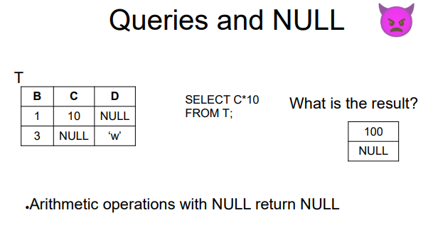

Expected one column with two tuples, one with 100 and one with NULL. Whenever you combine a NULL values with arithmetic operation you get NULL

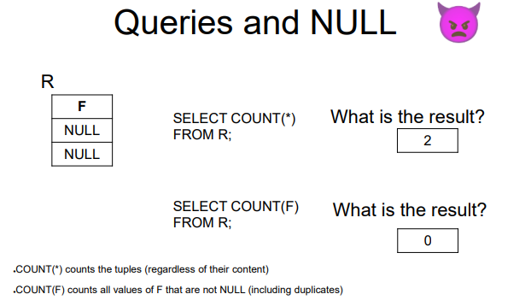
COUNT(*) ⟹ A table with one column and one row with a value 2. Count the number of tuples, no matter the value
COUNT(F) ⟹ count how many non null values.

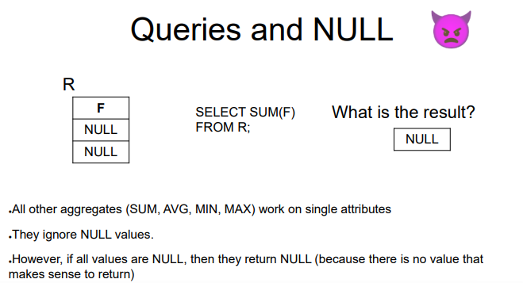
The result is NULL, because every other aggregate ignore NULL values, but if there are only NULL to sum the result is NULL

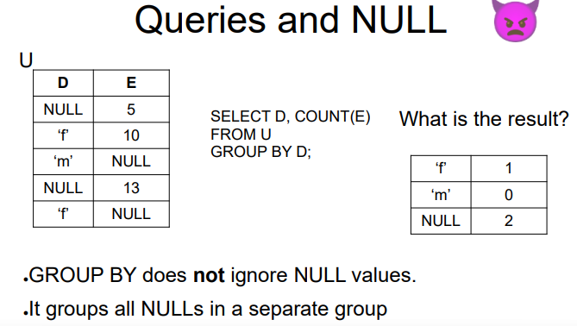
group all keeps NULL in a separate group.
- m is associated to 0 because COUNT always return a number

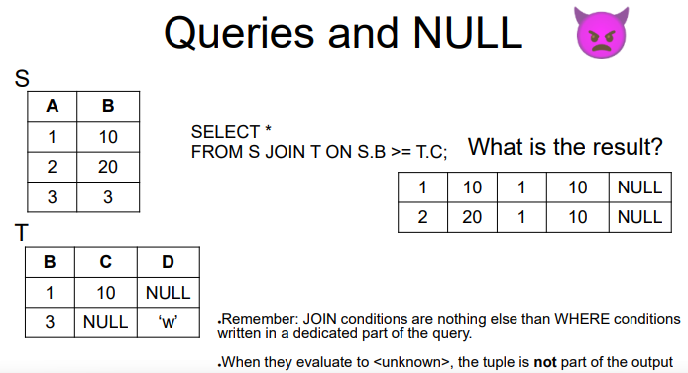

In the where condition everything that is not true is considered as false.
REMEMBER: ON is like where condition

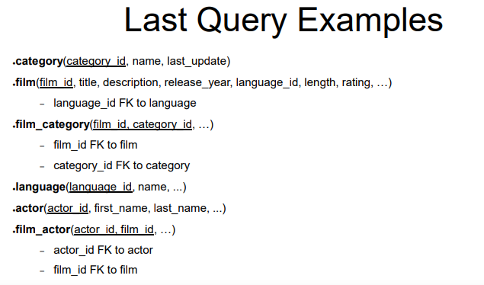

-- for each language return the number of movies in that language

SELECT l.language_id, max(l.name), count(film_id)
FROM language l LEFT JOIN film f ON l.language_id = f.language_id
GROUP BY l.language_id
order by l.name

-- do LEFT JOIN since there are some languages that have 0 movies but are still inside the dataset
-- the left join is like the normal join but if it does not find a match it adds a row.
-- left joint from language to film because language contain every language
-- if the left join does not find a match for a german film it will output "German" and 0 movies to show that there was no match

-- for each language, return the total length of the movies in that language
select l.language_id, sum(f.length)
from language l LEFT JOIN film f ON l.language_id = f.language_id
group by l.language_id

COALESCE
takes multiple values as input
coalesce( <value1>, <value2>, …)
it does a

if <value1> is not null then
return <value1>
else if <value2> is not null then
return <value2>
else if <value3> is not null then
return <value3>

…
else if <valuen> is not null then
return <valuen>
else
return null

⟹ coalesce return the first non-null value, if not present return null

We can use it like coalesce(sum(f.length), 0) ⟹ so that if the value is [null] it will return 0

-- for each actor having all its movies <= 170 minutes
-- return the total number of movies where the actor played

select distinct fa2.actor_id, count(fa2.film_id)
from film_actor fa2
where fa2.actor_id not in (
select actor_id
from film_actor fa LEFT JOIN film f ON f.film_id = fa.film_id
group by actor_id
having max(f.length) > 170
)
group by fa2.actor_id

